

Wimoto – ble smart device
user guide – ver 1.0.0

Table of Contents
`
1 Introduction……………………………………………………………………3
2 Initial Setup……………………………………………………………………3
3 Hardware Setup……………………………………………………………….4
3.1 Climate Profile…………………………………………………………………………..4
3.2 Grow Profile……………………………………………………………………………..4
3.3 Sentry Profile…………………………………………………………………………….7
3.4 Thermo Profile…………………………………………………………………………..6
3.5 Water Profile…………………………………………………………………………….7
4 Execution………………………………………………………………………8
4.1 Bootloader……………………………………………………………………………….8
4.2 Climate Profile…………………………………………………………………………..9
4.3 Grow Profile……………………………………………………………………………13
4.4 Sentry Profile ………………………………………………………………………….17
4.5 Thermo Profile…………………………………………………………………………20
4.6 Water Profile …………………………………………………………………………..23
5 Known Issues…………………………………………………………………26
6 Debugging…………………………………………………………………….26

7 Tables of UUID’s for all Profiles

Introduction

Wimoto is developing a smart device which integrates many sensors for BLE climate profile (temperature, humidity, light level), Grow profile (light, temperature, soil moisture) and Sentry profile (passive infrared, accelerometer), Thermo profile (probe (NT) C temperature, thermopile temperature) and Water Profile (water presence, water level) on Nordic semiconductor nrf51822 based hardware platform. This device can be configured and managed by corresponding app on mobile devices like iPhone, Android and a proprietary gateway.

This document provides details on how to get the source code working on the target hardware. This also provides details on how the source code is organized and what is to be done in case of any problems.

Initial Setup

- Download the code from the folder WimotoBle
- Install the required software.
  - Keil uVision
  - J-Link drivers for JTAG interface.
  - nRF51822 software
    - nRFgo Studio
    - nRF51 Software Development Kit (SDK)
    - S110 nRF51822 Soft Device
    - Master Control Panel v3.5 ( v3.5 has support for DFU API)
- Copy the folder ble_wimoto_clim_app / ble_wimoto_grow_app / ble_wimoto_water_app / ble_wimoto_thermo_app/ to the nrf51822\Board\pca10001\ble folder in the nrf51_sdk directory.
- Copy the device_firmware_updates to the nrf51822\Board\6310\ble folder in the nrf51_sdk directory for setting up the bootloader
- Open the project in Keil uVision.
- Build the project.

Hardware Setup

3.1 Climate Profile

Note: Since the HTU21D temperature and humidity sensor was not available, climate profile was not tested with sensors. However the embedded code was tested using hard coded values and the results were as expected and found to be working properly

3.2 Grow Profile
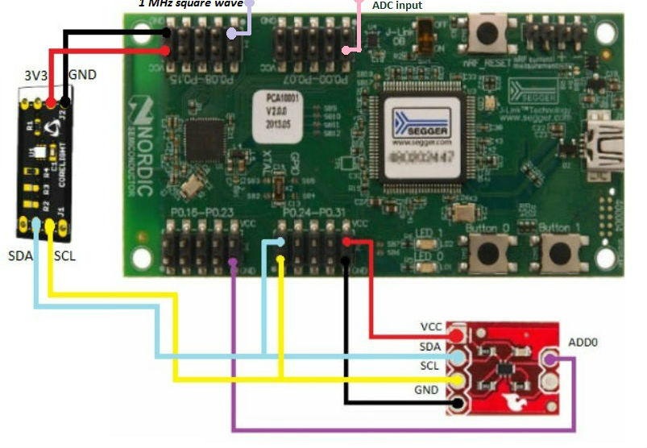
- Interface the TMP102 module, ISL29023 module and analogue Soil Moisture sensor with nRF51822 Evaluation Kit board as shown below
- Power up the board from USB attached to Windows PC.
- Do-not connect nRF51822 Development Dongle while programming nRF51822 Evaluation Kit board
- Download the hex file created to the evaluation board.

3.5 Sentry Profile

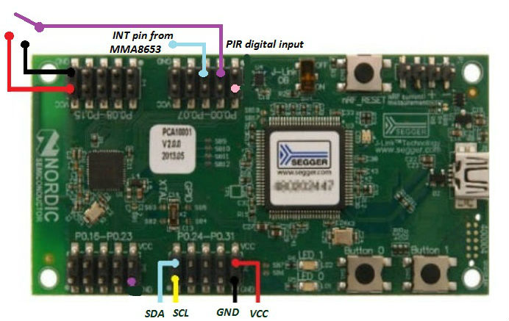

- Interface the sensors for the Sentry profile
- Power up the board from USB attached to Windows PC.
- Do-not connect nRF51822 Development Dongle while programming nRF51822 Evaluation Kit board
- Download the hex file created to the evaluation board.

Note: Since the MMA8653 accelerometer sensor was not available, Sentry profile was not tested with sensors. However the embedded code was tested using hard coded values and the results were as expected and found to be working properly

In the code if the MMA8653 driver fails to initialize a LED blinking functionality has been added in order to notify the error situation while testing

3.4 Thermo Profile

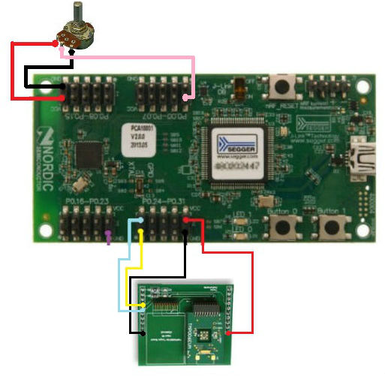

- Interface the sensors for the Thermo profile
- Power up the board from USB attached to Windows PC.
- Do-not connect nRF51822 Development Dongle while programming nRF51822 Evaluation Kit board
- Download the hex file created to the evaluation board.

3.3 Water Profile
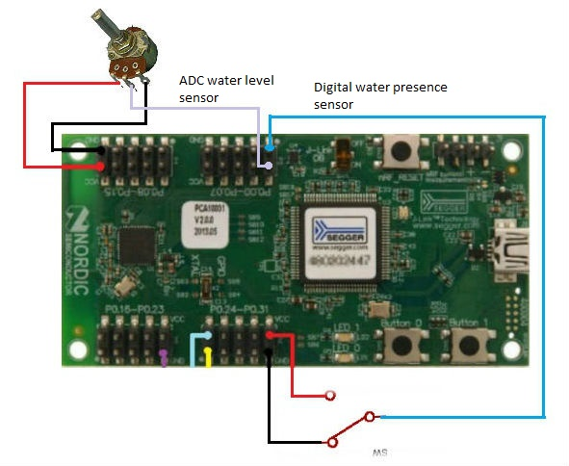
- Interface the sensors for the Water profile
- Power up the board from USB attached to Windows PC.
- Do-not connect nRF51822 Development Dongle while programming nRF51822 Evaluation Kit board
- Download the hex file created to the evaluation board.

Execution

4.1 Bootloader

- Power up the board from USB attached to Windows PC.
- Do-not connect nRF51822 Development Dongle while programming nRF51822 Evaluation Kit board
- Download the hex file created to the evaluation board
- For DFU right click on the master and select the option “Over the air DFU” , then from the new window select the ‘hex’ file of the new firmware to be uploaded. The hex files can be found in the build folder in the corresponding project file after a successful build.
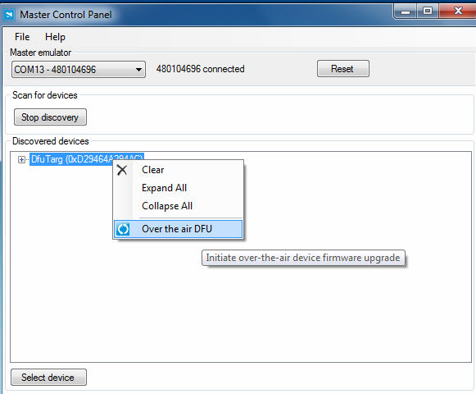

- After 100% done response close the DFU window and start the discovery so the Master Control Panel shows the new image updated

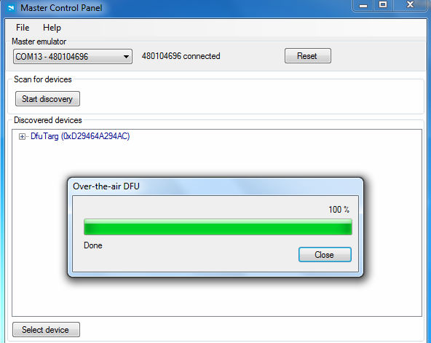

4.2Climate Profile

- Connect the nRF51822 Development Dongle to USB of the PC. Power up the evaluation board.
- Open the Master Control Panel version 3.5 in PC.(Provides the API for device firmware update)
- From the option 'Master Emulator', select the segger serial number of the development dongle and click 'Start Discovery'.
- Master control panel will show the Climate profile alarm service continuously
- To connect to the alarm service, select the device Wimoto_Clim and click 'Select device'.
- Click 'Service discovery'. All the characteristics in the service will be displayed. Click 'Enable services'.
- In the first primary service with Uuid E0035608 - EC48 - 4ED0 - 9F3B - 5419C00A94FD, six characteristic fields will be displayed.
Uuid E0035609 -EC48 -4ED0 - 9F3B-5419C00A94FD - Current Temperature
Uuid E003560A -EC48 - 4ED0 -9F3B-5419C00A94FD - Temperature low value (for alarm)
Uuid E003560B-EC48 - 4ED0 - 9F3B - 5419C00A94FD - Temperature high value(for alarm)
Uuid E003560C - EC48 - 4ED0 - 9F3B - 5419C00A94FD - Temperature Alarm set
Uuid E003560D - EC48 - 4ED0 - 9F3B - 5419C00A94FD - Temperature Alarm
- In the second primary service with Uuid E003560E - EC48 - 4ED0 - 9F3B - 5419C00A94FD, five characteristic fields will be displayed.
Uuid E003560F - EC48 - 4ED0 - 9F3B - 5419C00A94FD - Current Light level
Uuid E0035610 - EC48 - 4ED0 - 9F3B - 5419C00A94FD - Light level low value (for alarm)
Uuid E0035611- EC48 - 4ED0 - 9F3B - 5419C00A94FD - Light level high value (for alarm)
Uuid E0035612 - EC48 - 4ED0 - 9F3B - 5419C00A94FD - Light level Alarm set
Uuid E0035613 - EC48 - 4ED0 - 9F3B - 5419C00A94FD - Light level Alarm
- In the third primary service with Uuid E0035614 - EC48 - 4ED0 - 9F3B - 5419C00A94FD, five characteristic fields will be displayed.
Uuid E0035615 - EC48 - 4ED0 - 9F3B - 5419C00A94FD - Current Humidity level
Uuid E0035616 - EC48 - 4ED0 - 9F3B - 5419C00A94FD - Humidity low value (for alarm)
Uuid E0035617 - EC48 - 4ED0 - 9F3B - 5419C00A94FD - Humidity high value (for alarm)
Uuid E0035618 - EC48 - 4ED0 - 9F3B - 5419C00A94FD - Humidity Alarm set
Uuid E0035619 - EC48 - 4ED0 - 9F3B - 5419C00A94FD - Humidity Alarm

- In the fourth primary service with UUID E003561A - EC48 - 4ED0 - 9F3B - 5419C00A94FD the Data logger service is advertised. It contains three characteristic fields.
Uuid E003561B-EC48-4ED0-9F3B-5419C00A94FD - Enable data logger service
Uuid E003561C-EC48-4ED0-9F3B-5419C00A94FD - The data displayed when read
Uuid E003561D -EC48-4ED0-9F3B-5419C00A94FD - Read the logged data, set
- In the fifth primary service will Uuid E003561E - EC48 - 4ED0 - 9F3B - 5419C00A94FD, two characteristic fields will be displayed.
Uuid E003561F-EC48-4ED0-9F3B-5419C00A94FD - Device Firmware Update Mode Set
Uuid E0035620-EC48-4ED0-9F3B-5419C00A94FD - Switch Mode Set
Uuid 1805- Time Stamp
- In the Sixth primary service with Uuid 180A, three characteristic fields will be displayed.
Uuid 2A29- Manufacturer Name
Uuid 2A24- Model Number
Uuid 2A23- System ID
- In the Seventh primary service with Uuid 180F, characteristic field will be displayed.
Uuid 2A19- Battery Level
- The High and Low values for checking alarm condition in Temperature low/high, Light level low/high and Humidity low/high values can be set by, clicking on the corresponding characteristic field (UUID), enter a new value in the “value box” shown below the characteristics and click on 'Send update'
- To set alarm, change the Alarm set value (UUID E003560C-EC48-4ED0-9F3B- 5419C00A94FD -temperature/ E0035612-EC48-4ED0-9F3B-5419C00A94FD -light level/ E0035618-EC48-4ED0-9F3B-5419C00A94FD -humidity) to 01. If the current value read from the sensor is less that the low value, the Alarm field to the corresponding service (UUID E003560D-EC48-4ED0-9F3B-5419C00A94FD -temperature/ E0035613-EC48-4ED0-9F3B-5419C00A94FD -light level/ E0035619-EC48-4ED0-9F3B- 5419C00A94FD -humidity) will show 0x01. If the value read from the sensor is greater than the high value, the alarm field will show 0x02.
- To turn off the alarm, update the Alarm set field to 0x00 of the corresponding services.
- To go to the Device Firmware Update mode, set DFU Mode set value to 0x01 (UUID E003561F-EC48-4ED0-9F3B-5419C00A94FD) in Device management service and click 'disconnect', click 'back' and start discovery by clicking 'start discovery' . Then the boot loader gets loaded and by right clicking in the panel select the option “Over the air DFU” and browse for the new firmware to be loaded and update. The new firmware is the ‘hex’ file found in the ‘build’ folder of corresponding project. After 100% completion message the new firmware gets loaded on the device
- To go to the Broadcast mode, set Mode Switch set value to 0x01
(UUID E0035620-EC48-4ED0-9F3B-5419C00A94FD) in Device management service and click 'disconnect', click 'back' and start discovery by clicking 'start discovery' .
- In the Broadcast mode the data is advertised as manufacturing data since the custom services are not tied to any standard UUID. The battery service is advertised with UUID 0x180F. The battery level is shown as percentage value (100% is shown as 0x64)
The data format of custom data is
DE-AD -xx-xx - yy-yy - zz-zz

Company Identifier Temperature Light Humidity

- Time Stamp characteristic is used for real time tracking (Uuid 1805). This characteristic gets started when the device power up itself. User can also set the values for current time, year, day, month for so that the time tracking resumes from the user set value. The data format of time stamp is as flows
yy-yy - mm – dd – hr – min - sec
- The embedded application code stays in the Broadcast mode until a power on reset is incurred

- Data Logger Service
To enable data logger service, set the characteristics E003561B-EC48-4ED0-9F3B-5419C00A94FD to 0x01. The application will start logging data to the flash. To download data from the peripheral, set the characteristics E003561D-EC48-4ED0-9F3B-5419C00A94FD to 0x01. The application will the stop data logging and starts to send data to the connected central device. The data field is an unsigned integer array of size 16. The data format is as given below.

The 1st 2 bytes contains the year.
The 3rd byte contains the month.
The 4th byte contains day.
The 5th and 6th byte contains Hour.
The 7th byte contains Minutes.
The 8th byte contains Seconds.
The 9th and 10th bytes contains the temperature.
The 11th and 12th bytes contains light level.
The last 4 bytes contains the humidity level.

An example of the data array received in master control panel is 07DD0B15000B32000101020200000055 which is arranged as shown below

07DD 0B 15 000B 32 00 0101 0202 00000055

2013 11 21 11 50 00 temperature light level Humidity Level

4.3 Grow Profile

- Connect the nRF51822 Development Dongle to USB of the PC. Power up the evaluation board.
- Open the Master Control Panel in PC.
- From the option 'Master Emulator', select the segger serial number of the development dongle and click 'Start Discovery'.
- Master control panel will show the Grow profile alarm service continuously
- To connect to the alarm service, select the device Wimoto_Grow and click 'Select device'.
- Click 'Service discovery'. All the characteristics in the service will be displayed. Click 'Enable services'.
- In the first primary service with Uuid DAF44706–BFB0-4DD8–9293–62AF5F545E31, six characteristic fields will be displayed.
Uuid DAF44707– BFB0 – 4DD8 – 9293 – 62AF5F545E31 - Current Temperature
Uuid DAF44708– BFB0– 4DD8–9293–62AF5F545E31 - Temperature low value (for alarm)
Uuid DAF44709–BFB0–4DD8– 9293 – 62AF5F545E31- Temperature high value (for alarm)
Uuid DAF4470A – BFB0 – 4DD8 – 9293 – 62AF5F545E31- Temperature Alarm set
Uuid DAF4470B – BFB0 – 4DD8 – 9293 – 62AF5F545E31- Temperature Alarm
- In the second primary service with Uuid DAF4470C–BFB0–4DD8–9293–62AF5F545E31, five characteristic fields will be displayed.
Uuid DAF4470D – BFB0 – 4DD8 – 9293 – 62AF5F545E31- Current Light level
Uuid DAF4470E–BFB0 – 4DD8 – 9293 – 62AF5F545E31 - Light level low value (for alarm)
Uuid DAF4470F–BFB0– 4DD8 – 9293 – 62AF5F545E31 - Light level high value (for alarm)
Uuid DAF44710 – BFB0 – 4DD8 – 9293 – 62AF5F545E31 - Light level Alarm set
Uuid DAF44711 – BFB0 – 4DD8 – 9293 – 62AF5F545E31- Light level Alarm
- In the third primary service with Uuid DAF44712 – BFB0 – 4DD8 – 9293 – 62AF5F545E31, five characteristic fields will be displayed.
Uuid DAF44713 – BFB0 – 4DD8 – 9293 – 62AF5F545E31 - Current soil moisture level
Uuid DAF44714–BFB0–4DD8–9293–62AF5F545E31 - Soil moisture low value (for alarm)
Uuid DAF44715 – BFB0 – 4DD8 – 9293 – 62AF5F545E31- Soil moisture high value
Uuid DAF44716 – BFB0 – 4DD8 – 9293 – 62AF5F545E31- Soil moisture Alarm set
Uuid DAF44717 – BFB0 – 4DD8 – 9293 – 62AF5F545E31- Soil moisture Alarm
- In the fourth primary service with UUID DAF44718 – BFB0 – 4DD8 – 9293 – 62AF5F545E31, the Data logger service is advertised. It contains three characteristic fields.
Uuid DAF44719 – BFB0 – 4DD8 – 9293 – 62AF5F545E31 - Enable data logger service
Uuid DAF4471A – BFB0 – 4DD8 – 9293 – 62AF5F545E31 - The data displayed when read
Uuid DAF4471B – BFB0 – 4DD8 – 9293 – 62AF5F545E31 - Read the logged data, set
- In the fifth primary service with Uuid DAF4471C – BFB0 – 4DD8 – 9293 – 62AF5F545E31, two characteristic fields will be displayed.
Uuid DAF4471D–BFB0–4DD8–9293 – 62AF5F545E31- Device Firmware Update Mode Set
Uuid DAF4471E – BFB0 – 4DD8 – 9293 – 62AF5F545E31 - Switch Mode Set
Uuid 1805- Time Stamp

- In the Sixth primary service with Uuid 180A, three characteristic fields will be displayed.
Uuid 2A29- Manufacturer Name
Uuid 2A24- Model Number
Uuid 2A23- System ID
- In the Seventh primary service with Uuid 180F, characteristic field will be displayed.
Uuid 2A19- Battery Level
- The High and Low values for checking alarm condition in Temperature low/high, Light level low/high and Soil moisture low/high values can be set by, clicking on the corresponding characteristic field (UUID), enter a new value in the “value box” shown below the characteristics and click on 'Send update'
- To set alarm, change the Alarm set value (UUID DAF4470A – BFB0 – 4DD8 – 9293 – 62AF5F545E31-temperature/ DAF44710 – BFB0 – 4DD8 – 9293 – 62AF5F545E31-light level/ DAF44716 – BFB0 – 4DD8 – 9293 – 62AF5F545E31-soil moisture) to 01. If the current value read from the sensor is less that the low value, the Alarm field to the corresponding service (UUID DAF4470B–BFB0–4DD8–9293– 62AF5F545E31-temperature/ DAF44711–BFB0–4DD8–9293–62AF5F545E31-light level/ DAF44717– BFB0–4DD8– 9293–62AF5F545E31-soil moisture) will show 0x01. If the value read from the sensor is greater than the high value, the alarm field will show 0x02.
- To turn off the alarm, update the Alarm set field to 0x00 of the corresponding services.
- To go to the Device Firmware Update mode, set DFU Mode set value to 0x01 (UUID DAF4471D–BFB0–4DD8–9293–62AF5F545E31) in Device management service and click 'disconnect', click 'back' and start discovery by clicking 'start discovery' . Then the DFU image gets loaded and by right clicking in the panel select the option “Over the air DFU” and browse for the firmware to be loaded and update. After 100% completion message the new firmware gets loaded on the device
- To go to the Broadcast mode, set Mode Switch set value to 0x01 (UUID DAF4471E–BFB0–4DD8– 9293–62AF5F545E31) in Device management service and click 'disconnect', click 'back' and start discovery by clicking 'start discovery' .
- In the Broadcast mode the data is advertised as manufacturing data since the custom services are not tied to any standard UUID. The battery service is advertised with UUID 0x180F. The battery level is shown as percentage value (100% is shown as 0x64)
The data format of custom data is
DE-AD -xx-xx - yy-yy - zz

Company Identifier Temperature Light Soil Moisture
- Time Stamp characteristic is used for real time tracking (Uuid 1805). This characteristic gets started when the device power up itself. User can also set the values for current time, year, day, month for so that the time tracking resumes from the user set value. The data format of time stamp is as flows
yy-yy - mm – dd – hr – min - sec
- The embedded application code stays in the Broadcast mode until a power on reset is incurred

Data Logger Service
- To enable data logger service, set the characteristics DAF44719–BFB0–4DD8–9293– 62AF5F545E31 to 0x01. The application will start logging data to the flash. To download data from the peripheral, set the characteristics DAF4471B – BFB0 – 4DD8 – 9293 – 62AF5F545E31 to 0x01. The application will the stop data logging and starts to send data to the connected central device. The data field is an unsigned integer array of size 16. The data format is as given below.

The 1st 2 bytes contains the year.
The 3rd byte contains the month.
The 4th byte contains day.
The 5th and 6th byte contains Hour.
The 7th byte contains Minutes.
The 8th byte contains Seconds.
The 9th and 10th byte contains the temperature.
The 11th and 12th byte contains light level.
The last 4 bytes contains the soil moisture level.

An example of the data array received in master control panel is 07DD0B15000B32000101020200000003 which is arranged as shown below

07DD 0B 15 000B 32 00 0101 0202 000000 03

2013 11 21 11 50 00 temperature light level soil moisture level
(Time stamp)

4.4 Sentry Profile

- Connect the nRF51822 Development Dongle to USB of the PC. Power up the evaluation board.
- Open the Master Control Panel in PC.
- From the option 'Master Emulator', select the segger serial number of the development dongle and click 'Start Discovery'.
- Master control panel will show the Sentry profile alarm service continuously
- To connect to the alarm service, select the device Wimoto_Sentry and click 'Select device'.
- Click 'Service discovery'. All the characteristics in the service will be displayed. Click 'Enable services'.
- In the first primary service Uuid 4209DC68 - E433 – 4420 - 83D8 - CDAACCD2E312, four characteristic fields will be displayed.
Uuid 4209DC69 - E433–4420 - 83D8 - CDAACCD2E312- Current X, Y, Z acceleration data
Uuid 4209DC6A - E433 – 4420 - 83D8 - CDAACCD2E312- Movement alarm set
Uuid 4209DC6B - E433 – 4420 - 83D8 - CDAACCD2E312- Movement alarm clear
Uuid 4209DC6C - E433 – 4420 - 83D8 - CDAACCD2E312- Movement alarm
- In the second primary service Uuid 4209DC6D-E433–4420-83D8-CDAACCD2E312, three characteristic fields will be displayed.
Uuid 4209DC6E - E433 – 4420 - 83D8 - CDAACCD2E312- Current PIR state
Uuid 4209DC6F - E433 – 4420 - 83D8 - CDAACCD2E312- PIR Alarm set
Uuid 4209DC70 - E433 – 4420 - 83D8 - CDAACCD2E312- PIR Alarm
- In the third primary service Uuid 4209DC71 - E433 – 4420 - 83D8 - CDAACCD2E312, three characteristic fields will be displayed.
Uuid 4209DC72 - E433 – 4420 - 83D8 - CDAACCD2E312 - Enable data logger service
Uuid 4209DC73 - E433 – 4420 - 83D8 - CDAACCD2E312 - The data displayed when read
Uuid 4209DC74 - E433 – 4420 - 83D8 - CDAACCD2E312 - Read the logged data, set
- In the fourth primary service Uuid 4209DC75 - E433 – 4420 - 83D8 - CDAACCD2E312, two characteristic fields will be displayed.
Uuid 4209DC76-E433–4420- 83D8 - CDAACCD2E312- Device Firmware Update Mode Set
Uuid 4209DC77 - E433 – 4420 - 83D8 - CDAACCD2E312- Switch Mode Set
Uuid 1805- Time Stamp

- In the Fifth primary service with Uuid 180A, three characteristic fields will be displayed.
Uuid 2A29- Manufacturer Name
Uuid 2A24- Model Number
Uuid 2A23- System ID
- In the Sixth primary service with Uuid 180F, characteristic field will be displayed.
Uuid 2A19- Battery Level
- Current PIR State (Uuid 4209DC6E - E433 – 4420 - 83D8 - CDAACCD2E312) will be initialized to 0x00 and when the PIR sensor triggers an interrupt , Current PIR State will be set to 0x01
- Inputting values for the corresponding characteristics can be done by clicking on the corresponding characteristic field (UUID), enter a new value in the “value box” shown below the characteristics and click on 'Send update'
- To set alarm, change the Alarm set value (UUID 4209DC6A - E433 – 4420 - 83D8 - CDAACCD2E312 - Movement alarm /4209DC6F - E433 – 4420 - 83D8 - CDAACCD2E312- PIR Alarm set) to 01.If the logic level at pin P0.02 (for PIR sensor) is Logic High then PIR Alarm (Uuid 4209DC70 - E433 – 4420 - 83D8 - CDAACCD2E312) is set to 0x01. If the accelerometer detects a movement it generates a logic Low at pin P0.04 then Movement alarm (Uuid 4209DC6C - E433 – 4420 - 83D8 - CDAACCD2E312) is set to 0x01, also the current X, Y, Z acceleration data register values from MMA8653 are also displayed.
- To turn off the alarm, update the Alarm set field to 0x00 of the corresponding services.
- In Movement alarm service, there is an additional characteristic added ‘Movement Alarm Clear’ (Uuid 4209DC6B - E433 – 4420 - 83D8 - CDAACCD2E312). When this characteristic is set to 0x01 the Movement Alarm (4209DC6C - E433 – 4420 - 83D8 - CDAACCD2E312) gets reset to a value 0x00 and the Movement Alarm Clear also gets cleared (0x00). This is to explicitly specify that the alarm condition is understood by the user and it is not critical.
- To go to the Device Firmware Update mode, set DFU Mode set value to 0x01 (UUID 4209DC76 - E433 – 4420 - 83D8 - CDAACCD2E312) in Device management service and click 'disconnect', click 'back' and start discovery by clicking 'start discovery' . Then the DFU image gets loaded and by right clicking in the panel select the option “Over the air DFU” and browse for the firmware to be loaded and update. After 100% completion message the new firmware gets loaded on the device
- To go to the Broadcast mode, set Mode Switch set value to 0x01 (UUID 4209DC77- E433–4420- 83D8- CDAACCD2E312) and click 'disconnect', click 'back' and start discovery by clicking 'start discovery' .
- In the Broadcast mode the data is advertised as manufacturing data since the custom services are not tied to any standard UUID. The battery service is advertised with UUID 0x180F. The battery level is shown as percentage value (100% is shown as 0x64)
The data format of custom data is
DE-AD xx-yy-zz - zz

Company Identifier X, Y, Z acceleration data PIR detection
- Time Stamp characteristic is used for real time tracking (Uuid 1805). This characteristic gets started when the device power up itself. User can also set the values for current time, year, day, month for so that the time tracking resumes from the user set value. The data format of time stamp is as flows
yy-yy - mm – dd – hr – min - sec
- The embedded application code stays in the Broadcast mode until a power on reset is incurred
- Data Logger Service
To enable data logger service, set the characteristics 4209DC72 - E433 – 4420 - 83D8 - CDAACCD2E312 to 0x01. The application will start logging data to the flash. To download data from the peripheral, set the characteristics 4209DC74 - E433 – 4420 - 83D8 - CDAACCD2E312 to 0x01. The application will the stop data logging and starts to send data to the connected central device. The data field is an unsigned integer array of size 16. The data format is as given below

The 1st 2 bytes contains the year.
The 3rd byte contains the month.
The 4th byte contains day.
The 5th and 6th byte contains Hour.
The 7th byte contains Minutes.
The 8th byte contains Seconds.
The 9th -12th byte contains X , Y , Z data from MMA8653
The last 4 bytes contains the PIR state (0-No detection ,1-Detection)

An example of the data array received in master control panel is 07DD0B15000B32000000000100000001 which is arranged as shown below

07DD 0B 15 000B 32 00 00 00 00 01 000000 01

2013 11 21 11 50 00 X Y Z acceleration data PIR state
(Time stamp)

4.5 Thermo Profile

- Connect the nRF51822 Development Dongle to USB of the PC. Power up the evaluation board.
- Open the Master Control Panel in PC.
- From the option 'Master Emulator', select the segger serial number of the development dongle and click 'Start Discovery'.
- Master control panel will show the Thermo profile alarm service continuously
- To connect to the alarm service, select the device Wimoto_Thermo and click 'Select device'.
- Click 'Service discovery'. All the characteristics in the service will be displayed. Click 'Enable services'.
- In the first primary service will Uuid 497B8E4E - B61E - 4F82 - 8FE9 - B12CF2497338, six characteristic fields will be displayed.
Uuid 497B8E4F - B61E - 4F82 - 8FE9 - B12CF2497338- Current Thermopile Temperature
Uuid 497B8E50- B61E - 4F82 - 8FE9 - B12CF2497338- Thermopile Temperature low value ( for the alarm)
Uuid 497B8E51 - B61E - 4F82 - 8FE9 - B12CF2497338- Thermopile Temperature high value
Uuid 497B8E52 - B61E - 4F82 - 8FE9 - B12CF2497338- Thermopile Temperature Alarm set
Uuid 497B8E53 - B61E - 4F82 - 8FE9 - B12CF2497338- Thermopile Temperature
- In the second primary service will Uuid 497B8E54-B61E-4F82-8FE9- B12CF2497338, five characteristic fields will be displayed.
Uuid 497B8E55 - B61E - 4F82 - 8FE9 - B12CF2497338- Current Probe Temperature level
Uuid 497B8E56 - B61E - 4F82 - 8FE9 - B12CF2497338- Probe Temperature level low value (for the alarm)
Uuid 497B8E57 - B61E - 4F82 - 8FE9 - B12CF2497338- Probe Temperature level high value
Uuid 497B8E58 - B61E - 4F82 - 8FE9 - B12CF2497338- Probe Temperature level Alarm set
Uuid 497B8E59 - B61E - 4F82 - 8FE9 - B12CF2497338- Probe Temperature level Alarm
- In the third primary service will Uuid 497B8E5A - B61E - 4F82 - 8FE9 - B12CF2497338, three characteristic fields will be displayed.
Uuid 497B8E5B - B61E - 4F82 - 8FE9 - B12CF2497338- Enable data logger service
Uuid 497B8E5C - B61E - 4F82 - 8FE9 - B12CF2497338- The data displayed when read
Uuid 497B8E5D - B61E - 4F82 - 8FE9 - B12CF2497338- Read the logged data, set

- In the fourth primary service with Uuid 497B8E5E - B61E - 4F82 - 8FE9 - B12CF2497338, two characteristic fields will be displayed.
Uuid 497B8E5F - B61E - 4F82 - 8FE9 - B12CF2497338- Device Firmware Update Mode Set
Uuid 497B8E60 - B61E - 4F82 - 8FE9 - B12CF2497338- Switch Mode Set
Uuid 1805- Time Stamp

- In the Fifth primary service with Uuid 180A, three characteristic fields will be displayed.
Uuid 2A29- Manufacturer Name
Uuid 2A24- Model Number
Uuid 2A23- System ID
- In the Sixth primary service with Uuid 180F, characteristic field will be displayed.
Uuid 2A19- Battery Level
- The High and Low values for checking alarm condition in Thermopile Temperature low/high, Probe Temperature level low/high values can be set by, clicking on the corresponding characteristic field (UUID), enter a new value in the “value box” shown below the characteristics and click on 'Send update'
- The Thermopile Temperature is represented as a string where the corresponding hex value of each character is displayed instead the digit
( for example 30.29 is represented as “33 30 2E 32 39”) so while setting the values for low and high Thermopile Temperature this convention has to be followed
- To set alarm, change the Alarm set value (UUID 497B8E52 - B61E - 4F82 - 8FE9 - B12CF2497338- Thermopile Temperature /497B8E58 - B61E - 4F82 - 8FE9 - B12CF2497338- Probe Temperature) to 01. If the current value read from the sensor is less that the low value, the Alarm field to the corresponding service (UUID 497B8E53 - B61E - 4F82 - 8FE9 - B12CF2497338- Thermopile Temperature /497B8E59 - B61E - 4F82 - 8FE9 - B12CF2497338- Probe Temperature) will show 0x01. If the value read from the sensor is greater than the high value, the alarm field will show 0x02.
- To turn off the alarm, update the Alarm set field to 0x00 of the corresponding services.
- To go to the Device Firmware Update mode, set DFU Mode set value to 0x01 (UUID 497B8E5F - B61E - 4F82 - 8FE9 - B12CF2497338) in Device management service and click 'disconnect', click 'back' and start discovery by clicking 'start discovery' . Then the DFU image gets loaded and by right clicking in the panel select the option “Over the air DFU” and browse for the firmware to be loaded and update. After 100% completion message the new firmware gets loaded on the device
- To go to the Broadcast mode, set Mode Switch set value to 0x01 (UUID 497B8E60 - B61E - 4F82 - 8FE9 - B12CF2497338) and click 'disconnect', click 'back' and start discovery by clicking 'start discovery' .
- In the Broadcast mode the data is advertised as manufacturing data since the custom services are not tied to any standard UUID. The battery service is advertised with UUID 0x180F. The battery level is shown as percentage value (100% is shown as 0x64)
The data format of custom data is
DE-AD -ww-xx-2E-yy-zz - mm

Company Identifier Thermopile temperature Probe Temperature
- Time Stamp characteristic is used for real time tracking (Uuid 1805). This characteristic gets started when the device power up itself. User can also set the values for current time, year, day, month for so that the time tracking resumes from the user set value. The data format of time stamp is as flows
yy-yy - mm – dd – hr – min - sec
- The embedded application code stays in the Broadcast mode until a power on reset is incurred

- Data Logger Service
To enable data logger service, set the characteristics 497B8E5B - B61E - 4F82 - 8FE9 - B12CF2497338 to 0x01. The application will start logging data to the flash. To download data from the peripheral, set the characteristics 497B8E5D - B61E - 4F82 - 8FE9 - B12CF2497338 to 0x01. The application will the stop data logging and starts to send data to the connected central device. The data field is an unsigned integer array of size 16. The data format is as given below.

The 1st 2 bytes contains the year.
The 3rd byte contains the month.
The 4th byte contains day.
The 5th and 6th byte contains Hour.
The 7th byte contains Minutes.
The 8th byte contains Seconds.
The 9th -12th byte contains target temperature
The last 4 bytes contains the probe temperature (8 bit value from ADC)
An example of the data array received in master control panel is
07DD0B15000B320033302E3238000053 which is arranged as shown below
07DD 0B 15 000B 32 00 33 30 2E 32 38 0000 53

2013 11 21 11 50 00 Target temperature(30.28°C) Probe temperature
(Time stamp)

4.6 Water Profile

- Connect the nRF51822 Development Dongle to USB of the PC. Power up the evaluation board.
- Open the Master Control Panel in PC.
- From the option 'Master Emulator', select the segger serial number of the development dongle and click 'Start Discovery'.
- Master control panel will show the Water profile alarm service continuously
- To connect to the alarm service, select the device Wimoto_Water and click 'Select device'.
- Click 'Service discovery'. All the characteristics in the service will be displayed. Click 'Enable services'.
- In the first primary service will Uuid 35D8C7DB- 9D78 - 43C2 - AB2E - 0E48CAC2DBDA, six characteristic fields will be displayed.
Uuid 35D8C7DC - 9D78 - 43C2 - AB2E - 0E48CAC2DBDA - Current Water Presence
Uuid 35D8C7DD - 9D78 - 43C2 - AB2E - 0E48CAC2DBDA - Water Presence Alarm Set
Uuid 35D8C7DE - 9D78 - 43C2 - AB2E - 0E48CAC2DBDA - Water Presence Alarm
- In the second primary service will Uuid 35D8C7DF-9D78-43C2 -AB2E - 0E48CAC2DBDA, five characteristic fields will be displayed.
Uuid 35D8C7E0 - 9D78 - 43C2 - AB2E - 0E48CAC2DBDA - Current Water level
Uuid 35D8C7E1 - 9D78 - 43C2 - AB2E - 0E48CAC2DBDA - Water level low value (for the alarm)
Uuid 35D8C7E2 - 9D78 - 43C2 - AB2E - 0E48CAC2DBDA - Water level high value
Uuid 35D8C7E3 - 9D78 - 43C2 - AB2E - 0E48CAC2DBDA - Water level Alarm set
Uuid 35D8C7E4 - 9D78 - 43C2 - AB2E - 0E48CAC2DBDA - Water level Alarm
- In the third primary service will Uuid 35D8C7E5-9D78- 43C2 - AB2E - 0E48CAC2DBDA, three characteristic fields will be displayed.
Uuid 35D8C7E6 - 9D78 - 43C2 - AB2E - 0E48CAC2DBDA - Enable data logger service
Uuid 35D8C7E7 - 9D78 - 43C2 - AB2E - 0E48CAC2DBDA - The data displayed when read
Uuid 35D8C7E8 - 9D78 - 43C2 - AB2E - 0E48CAC2DBDA - Read the logged data, set
- In the fourth primary service with Uuid 35D8C7E9-9D78- 43C2 - AB2E - 0E48CAC2DBDA, two characteristic fields will be displayed.
Uuid 35D8C7EA-9D78-43C2-AB2E-0E48CAC2DBDA- Device Firmware Update Mode Set
Uuid 35D8C7EB - 9D78 - 43C2 - AB2E - 0E48CAC2DBDA - Switch Mode Set
Uuid 1805- Time Stamp
- In the Fifth primary service with Uuid 180A, three characteristic fields will be displayed.
Uuid 2A29- Manufacturer Name
Uuid 2A24- Model Number
Uuid 2A23- System ID
- In the Sixth primary service with Uuid 180F, characteristic field will be displayed.
Uuid 2A19- Battery Level
- The High and Low values for checking alarm condition in Water level low/high values can be set by, clicking on the corresponding characteristic field (UUID), enter a new value in the “value box” shown below the characteristics and click on 'Send update'
- To set alarm, change the Alarm set value (UUID 35D8C7DD - 9D78 - 43C2 - AB2E - 0E48CAC2DBDA -water presence/ UUID 35D8C7E3 - 9D78 - 43C2 - AB2E - 0E48CAC2DBDA water level) to 01. If the current value read from the sensor is less that the low value, the Alarm field to the corresponding service (UUID 35D8C7DE - 9D78 - 43C2 - AB2E - 0E48CAC2DBDA -water presence/ UUID 35D8C7E3 - 9D78 - 43C2 - AB2E - 0E48CAC2DBDA water level) will show 0x01. If the value read from the sensor is greater than the high value, the alarm field will show 0x02.
- To turn off the alarm, update the Alarm set field to 0x00 of the corresponding services.
- To go to the Device Firmware Update mode, set DFU Mode set value to 0x01 (UUID 35D8C7EA - 9D78 - 43C2 - AB2E - 0E48CAC2DBDA) in Device management service and click 'disconnect', click 'back' and start discovery by clicking 'start discovery' . Then the DFU image gets loaded and by right clicking in the panel select the option “Over the air DFU” and browse for the firmware to be loaded and update. After 100% completion message the new firmware gets loaded on the device
- To go to the Broadcast mode, set Mode Switch in Water level service to 0x01 (UUID 35D8C7EB - 9D78 - 43C2 - AB2E - 0E48CAC2DBDA) and click 'disconnect', click 'back' and start discovery by clicking 'start discovery' .
- In the Broadcast mode the data is advertised as manufacturing data since the custom services are not tied to any standard UUID. The battery service is advertised with UUID 0x180F. The battery level is shown as percentage value (100% is shown as 0x64)
The data format of custom data is
DE-AD -xx- -yy-

Company Identifier Water Presence Water Level
- Time Stamp characteristic is used for real time tracking (Uuid 1805). This characteristic gets started when the device power up itself. User can also set the values for current time, year, day, month for so that the time tracking resumes from the user set value. The data format of time stamp is as flows
yy-yy - mm – dd – hr – min - sec
- The embedded application code stays in the Broadcast mode until a power on reset is incurred

- Data Logger Service
To enable data logger service, set the characteristics 1901(En) to 0x01. The application will start logging data to the flash. To download data from the peripheral, set the characteristics 1903(Do) to 0x01. The application will the stop data logging and starts to send data to the connected central device. The data field is an unsigned integer array of size 16. The data format is as given below. Currently the time stamp is hardcoded to
2013-11-21 11:50:00, since the real time clock is not yet realized.

The 1st 2 bytes contains the year.
The 3rd byte contains the month.
The 4th byte contains day.
The 5th and 6th byte contains Hour.
The 7th byte contains Minutes.
The 8th byte contains Seconds.
The 9th -12th byte contains water presence. (1- water present, 0 - water not present)
The last 4 bytes contains the water level. (8 bit value from ADC)

An example of the data array received in master control panel is
07DD0B15000B32000000000100000053 which is arranged as shown below

07DD 0B 15 000B 32 00 000000 01 000000 53

2013 11 21 11 50 00 water presence water level
(Time stamp)

Known Issues

No known issues currently.

Debugging

If the Master Control panel (MCP) is not detecting the development dongle when both the dongle and evaluation board are connected to the PC, close the Master Control panel first. Then unplug both the boards. Then plug only the development dongle and open MCP. The MCP will now detect the dongle.

